Taylor Johnson

November 5th 2023

Software Engineering – Lab 3

Prof. Marcus Gubanyi

Lab 3+ – Pygame Tutorial

1. **Introductions:**
   1. **High-Level Description of the System:** The Pygame tutorial teaches you how games are developed using the Python programming language. It covers a wide range of topics, including player movement, enemy implementation, and random event generation. The tutorial introduces the concept of sprites and explains how they are used in Pygame games. In this particular game, you take control of a plane that responds to the user's inputs. Your objective is to showcase your piloting skills and survive for as long as possible, navigating through rockets that is constant threat. The challenge lies in avoiding any collision with the rockets, as even a single impact would lead to an automatic exit from the game.
2. **Time Log:**
   1. I created an excel sheet that kept track of all of my hours. The file will be attached with the assignment.
3. **System Overview:**
   1. **Describe the system that you built in more detail:** 
      1. As previously mentioned in the previous section, Sprite played a significant role in the development of Pygame. Sprites are used in Python for the purpose of representing characters, objects, or interactive elements within games or applications. Their functionality is used in a wide range of actions, such as movement, animation, rotation, and interaction, which contribute to the creation of captivating visual effects and engaging gameplay. In the Pygame tutorial, sprites were used for movement of the primary plane and to navigate the movements of enemies (rockets) and clouds across the screen. This implementation of sprites enhanced the overall experience for the users.
   2. **Include informal description of functional and non-functional requirements:**
      1. **Functional Requirement:** The ship must move up/down and left/right when users click the arrow keys.
      2. **Non-functional Requirement:** You must install Pygame in the directory where the game is going to be ran.
   3. **Include at least one structural diagram for your system:**

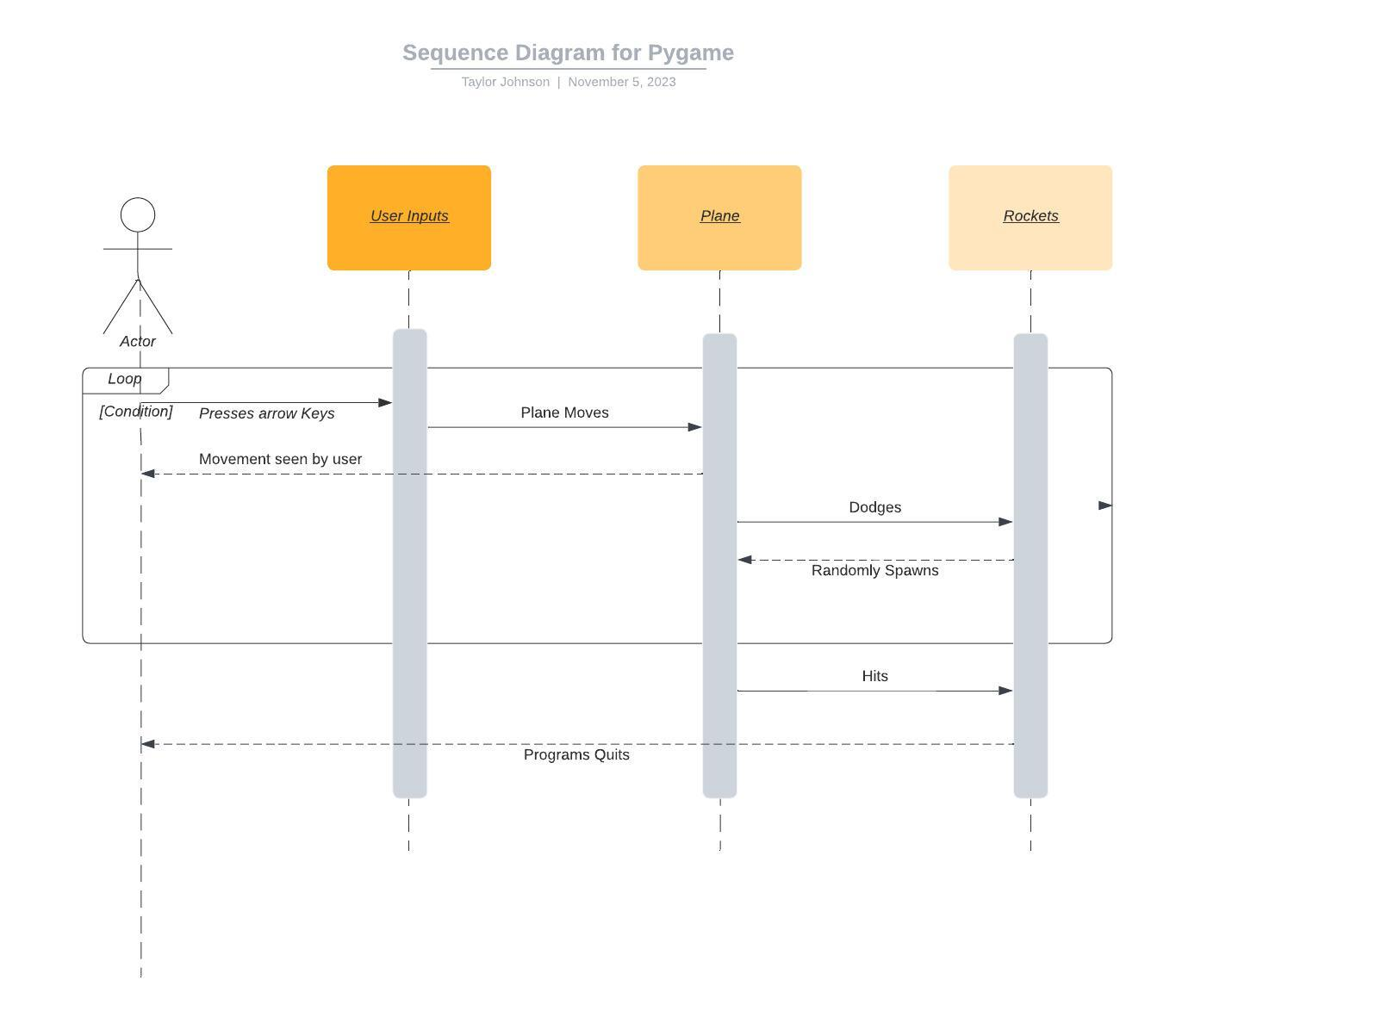

1. **Reflection:**
   1. **Describe what you learned by following this tutorial:**
      1. Something I gained from this tutorial is the importance of Sprites in game development using Python. Sprites help the visual elements and overall gameplay experience of a game. They allow developers to incorporate dynamic and interactive elements into their games, bringing characters, objects, and animations to life. By utilizing Sprites effectively, developers can create visually appealing and engaging games that captivate players. Another part of the tutorial that caught my attention was the concept of collision detection. I found it interesting because it allows for the detection and response to objects intersecting with each other. This plays a crucial role in this application because it can detect when the plain runs into a rocket. By implementing collision detection, it can create more realistic environments where objects interact realistically with one another.
   2. **Would you recommend this tutorial? Why or why not?** 
      1. I would highly recommend this tutorial because I believe it provides an excellent foundation for learning game development. While it may not cover every aspect or platform in game creation, understanding sprites and collision detection will be beneficial when working on various game projects. These concepts contribute to your overall proficiency in game development.
2. **References:** 
   1. **https://realpython.com/pygame-a-primer/#using-blit-and-flip**